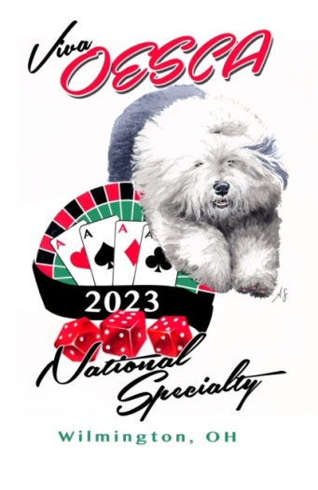
2023 Trophy Contribution

As a valued donor, you will receive special mention in the show catalog. Please fill out information for the catalog below.

Any donation is appreciated!

Cash, Check, and PayPal Accepted

Donations are welcome at any time,
but to be included in the catalog, money must be received by August 1, 2023.

Please make checks payable to “OESCA National Specialty” with notation “Trophy Donation”.
*Checks must be drawn on US funds and in US dollars*

Send Donation Checks to:
Denisse Onate
303 Rogers Court
Castle Rock, CO 80104
delozanov@hotmail.com
Please send PayPal donations to chsheepdogs@yahoo.com with notation “Trophy Donation”.
*Money must be in US Dollars* www.paypal.com
-----------------------------------------------------------------------------------------------------------------------------
2023 National Specialty Trophy Contribution Form

Name(s): ______________________________________________________________
Kennel Name: __________________________________________________________
Honorarium or Memorial Notation: ________________________________________
Address: _______________________________________________________________
Phone: ________________________________________________________________
Email: _________________________________________________________________
Amount:_______________________________________________________________

