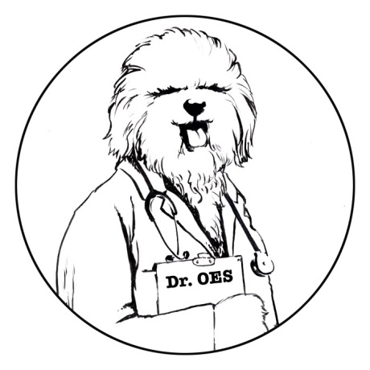
Ask Dr. OES

Introducing a New Column from the Health and Research Committee (HRC)

Each issue of the OET will have this new Question and Answer section.

Anything you ever wanted to know about the health of your Old English Sheepdog will be answered here by knowledgeable individuals providing current and accurate information.

Questions can be emailed to oeshealth@gmail.com.
Your questions will be published anonymously. Ask anything; the HRC will answer!

Question 1: I’m confused about “cleared by parentage”. What exactly does it mean?
Also, I’ve heard recently cleared by parentage is only good for 1 generation. Why is that?

Answer 1: “Cleared by parentage” means that the offspring can be considered clear of a hereditary disease (without being tested) if both the sire and dam have tested "clear" for that specific disease by DNA tests. Every dog has 2 copies of each gene.
CLEAR means that the dog has two copies of a normal (unmutated) gene.
The probability of passing down a mutation of this gene to the offspring is negligible.
CARRIERS have 1 normal copy and 1 mutated copy of a specific gene.
The probability of passing on the mutated gene is 50%.
AFFECTED dogs have 2 copies of the mutated gene. They will exhibit clinical signs of the disease.
The probability of passing on this particular gene to the offspring is 100%.

Frequency of gene mutation occurring in offspring from these breeding pairs:

 | CLEAR SIRE | CARRIER SIRE | AFFECTED SIRE
CLEAR DAM | 100% of offspring will be CLEAR | 50% of offspring will be CLEAR  50% of offspring will be CARRIERS | 100% of offspring will be CARRIERS
CARRIER DAM | 50% of offspring will be CLEAR  50% of offspring will be CARRIERS | 25% of offspring will be CLEAR  50% of offspring will be CARRIERS  25% of offspring will be AFFECTED | 50% of offspring will be CARRIERS  50% of offspring will be AFFECTED
AFFECTED DAM | 100% of offspring will be CARRIERS | 50% of offspring will be CARRIERS  50% of offspring will be AFFECTED | 100% of offspring will be AFFECTED

The OFA (Orthopedic Foundation of Animals) will only certify the first generation of untested offspring from a clear sire and a clear dam if both of their test results have been registered with the OFA, and if all three dogs (sire/dam/offspring) have been DNA-identity profiled and parentage verified. The OFA certification will carry the suffix "CBP" (clear by parentage) indicating that the dog itself was not tested and that the clearance is based on the test results of the sire and dam and known inheritance patterns at the time the clearance is issued.

One reason “cleared by parentage” is only good for one generation is that mistakes are made, such as an error in the lab, but the main one is that genetic mutations appear spontaneously and unpredictably.

Question 2: How do genetic mutations occur?

Answer 2: A genetic mutation is a permanent change in the DNA sequence of a gene. Occurring randomly, mutations are due to mistakes made by the cell when copying or reading DNA for cell division and can be inherited or acquired. Inherited mutations come from one or both parents and are passed to the offspring. Some inherited mutations can be found
through DNA testing of the parents and are the ones we are concerned with when breeding (such as EIC and CA). Acquired mutations
happen at some point during a lifetime, occur from an environmental factor (e.g. sun exposure), and are not passed to the offspring.

A more rare, but interesting mutation is the de novo (new) mutation. These mutations occur only in an egg or sperm cell, or immediately after fertilization. This type of mutation may explain why some offspring have a particular disease, even though the parents do not.

Question 3: Are all mutations harmful?

Answer 3: No, not all mutations are harmful. Actually, some mutations are helpful. Mutations that enhance an animal’s ability to survive are beneficial. For example, if a mutation occurred that helped an animal hear or see better, animals with that mutation may survive longer in the wild and produce more offspring than animals without that mutation.

