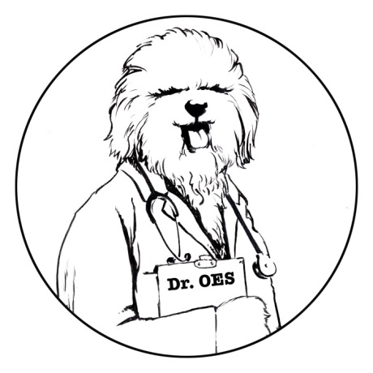
Ask Dr. OES

Introducing a New Column from the Health and Research Committee (HRC)

Each issue of the OET will have this new Question and Answer section.

Anything you ever wanted to know about the health of your Old English Sheepdog will be answered here by knowledgeable individuals providing current and accurate information.

Questions can be emailed to oeshealth@gmail.com.

Your questions will be published anonymously. Ask anything; the HRC will answer!

Question 1: What does “equivocal” mean in Autoimmune Hypothyroid Tests?

Answer 1: Equivocal means that the laboratory results are questionable, not definitive. The test should be repeated in 3 to 6 months. The stages of disease progression have been studied by Michigan State University (as stated below) using tissue samples examined by microscopy.

- At the very beginning of thyroid failure, localized lymphocytic (T and B cells) infiltration occurs. The Thyroid Autoantibodies (TgAA) are positive, although TSH (Thyroid Stimulating Hormone) and T4 and T3 (thyroid hormones) levels are normal. Typically the OFA classifies this as “Positive Compensative Autoimmune Thyroiditis”; however, some dogs may have TgAA titers in the equivocal range and be classified as “Equivocal”.¹

- The next stage is also classified by the OFA as “Positive Compensative Autoimmune Thyroiditis”. The lymphocytic infiltration is more widespread, and hormone production is affected. To compensate, the pituitary gland increases TSH secretion to stimulate more T4 and T3 production. TgAA is positive, TSH is elevated, but T4 and T3 levels remain normal.¹

- In the final stage, the lymphocytes have invaded most of the thyroid. Since so few normal thyroid cells have survived, the thyroid can no longer produce enough hormones. Until now, T4 and T3 have been normal. At this point, TgAA is still positive, TSH is still elevated, but, for the first time, T4 and T3 levels are low. OFA classifies this stage as “Positive Autoimmune Thyroiditis”.¹

The best test for detecting Autoimmune Thyroiditis is TgAA. Within the past several years, this test has been improved to reduce the number of false positives and equivocals by the addition of a negative control. Factors that can affect the negative control, and thus produce false positives and equivocals, include anything that stimulates the immune response, such as a vaccination, wound, or disease.¹

Drugs can also have an effect on thyroid function and may give equivocal results. Some common drugs known to affect the thyroid include glucocorticoids (such as prednisone and dexamethasone) which depress T4 and may decrease TSH. Sulfonamides (“sulfa drugs”) may cause clinical signs of hypothyroidism and positive results on thyroid tests; however, once sulfonamides are discontinued, all symptoms cease and tests results revert back to normal. Phenobarbital can decrease T4 and increase TSH. Carprofen (Rimadyl, Novox, Vetprofen) may decrease T4. Clomipramine (Anafanil, Clomicalm) can decrease T4 while TSH remains normal.²

References:
- Nachreiner, R 2009, ‘Autoimmune Thyroid Disease: Phenotype Testing and Evidence of a Genetic Component’, paper presented to the Tufts’ Canine and Feline Breeding and Genetics Conference, Sturbridge MA, 2009. Viewed 23 May 2018.
- Peterson, M. Hypothyroidism [Internet]. Kenilworth (NJ): Merck Veterinary Manual; 2018 [cited 23 May 2018]. Available from https://www.merckvetmanual.com/endocrine-system/the-thyroid-gland/hypothyroidism.

Question 2: If Autoimmune Hypothyroidism can be treated with medication, why do I need to worry about breeding a dog that has it?

Answer 2: Autoimmune Hypothyroidism affects many systems of the body, including reproduction. Even if a bitch is on medication to supplement her thyroid hormones, several problems can arise during breeding and pregnancy including fertility issues, small litter sizes, and low birth weights. Unbalanced thyroid hormones, whether hypo- or hyper- thyroid, result in a dog whose performance is less than ideal. In stressful situations, the body is pushed to maintain regular function.

While living a normal life is possible on thyroid medication, the body has to work harder to maintain balance. Since the thyroid regulates the whole body, any change has profound effects, and subtle changes are not always managed by medication. Clinical signs are lessened with medication, but the dog may never recover optimal function.

Something to consider: Older, previously-untested dogs exhibiting hypothyroid symptoms may have undiagnosed autoimmune hypothyroidism. They test negative for the autoantibodies because the thyroid was destroyed earlier in life.

