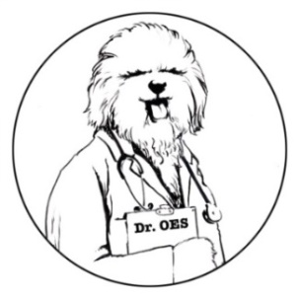
Ask Dr. OES
A Column from the Health and Research Committee
Send your questions to oeshealth@gmail.com.

Dear Dr. OES,
With all the genetic testing companies offering panels of tests, how do I know which ones are appropriate for my Old English Sheepdog?
So Many Choices in Overwhelmed, NM

Dear So Many Choices,
You are smart in asking about the panels of genetic tests. Many of the tests are not breed-specific and have no relevance to our beautiful breed. The results you receive from these panels need to be examined closely. Many companies find it more economical to run a wide array of genetic tests rather than screening for the genetic diseases that impact specific breeds.
These are the genetic tests relevant for OES:
Exercise Induced Collapse (EIC)
Primary Ciliary Dyskinesia (PCD)
Multiple Drug Sensitivity (MDR-1)
Cerebellar (Ataxia) Abiotrophy (CA)
Several companies do genetic testing, but most offer them as a package or panel. For example, the Wisdom Panel tests for over 180 genetic diseases, and Embark tests for over 170. PawPrint Genetics offers a panel for Old English Sheepdogs consisting of AMS (Acral Lick Mutilation Syndrome), DM (Degenerative Myelopathy), EIC, MDR1, and PCD. It is very important to note that of these tests, the only relevant ones are EIC, MDR1, and PCD. The other two genetic diseases they test for, AMS and DM, have never been seen in OES.
Some people confuse DM with CA. These are two separate genetic disorders located on different genes. While CA is a relevant test for OES, DM is not. The Orthopedic Foundation for Animals recommends the North Carolina State University lab for CA testing.
Unless the test has been validated for your specific breed, it is of little use. Genetic mutations causing disease in one breed are not always associated with disease in another breed. Many OES people have donated samples to develop genetic tests for PCD, CA, MDR1, and EIC for use in OES.

Although the panels are often cheaper for the owner to buy rather than picking individual tests, be aware that the results do not mean anything unless they are for diseases found in Old English Sheepdogs.
Usually a veterinarian with advanced study in genetics is required to interpret and advise owners who encounter a genetic disease. Schools of Veterinary Medicine can assist you in contacting a Genetics Specialist. You can also ask any of the HRC members to help you find the necessary resources to explain your test results.
Definitely do the genetic testing, but remember understanding the results is of great importance.
Dr. OES

