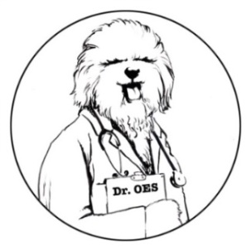
Dear Dr. OES,
Ask Dr. OES
A Column from the Health and Research Committee
Send your questions to oeshealth@gmail.com.
I’ve heard of breeders doing ENS with puppies but I’m not exactly sure what that is or if I should do it. What is your suggestion?
Puppies Are Coming in Puppyville, NM

Dear Puppies,
Early Neurological Stimulation (ENS) for puppies takes place when the puppies are 3-16 days old. Rapid neurological development is occurring during this time. Performing these five ENS exercises daily has shown to be very beneficial emotionally and physically. Puppies exposed to small stressors during this developmental period are better able to cope with stressful situations later in life in addition to having stronger immune systems.
Dr. Carmen Battaglia developed this protocol and the US Military has used it to improve the performance of their working dogs.
The 5 ENS exercises are briefly described below. They are performed once daily for 3-5 seconds each. Over stimulation can have adverse effects so it is important to perform these only once a day and no longer than the recommended time.
- Tactile Stimulation—While holding the puppy in one hand, gently tickle in between the toes on one foot with a Q-Tip.
- Head Held Erect—Using both hands, hold the puppy perpendicular to the floor with his head directly above his tail.
- Head Pointed Down—Using both hands, hold the puppy upside down with his tail directly above his head.
- Supine Positon—Hold the puppy in both hands on his back with his face pointed towards the ceiling.
- Thermal Stimulation—Place the puppy feet down on a cool damp towel.
Please read Dr. Carmen Battaglia’s protocol in its entirety as it gives a more detailed explanation of the procedure and the science behind it.

https://breedingbetterdogs.com/article/early-neurological-stimulation
Dr. OES

Dear Dr. OES,
I just read about a new disease called Acral Lick Mutilation Syndrome that OES can get. What should I do? Do I need to be tested?
Shaking In My Boots in Schenectady, NY

Dear Shaking,
Acral Mutilation Syndrome (AMS) is an inherited disorder that usually shows up during the first year of life. Because the dog lacks the feeling of pain in his feet and lower limbs, this self-mutilation disorder can result in the dog biting his feet and legs and actually chewing and biting the skin until it is damaged.

Please don’t confuse this disorder with licking and chewing of the feet due to allergies.

Right now the AMS genetic test is for a disease that is not present in Old English Sheepdogs. IT IS a disease in other breeds, but not in OES. The test does not relate to any disease that we see in our breed, and furthermore, the genes being tested do not correlate with any known disease in OES.

If anyone is concerned about their dog showing symptoms, please contact a member of the HRC directly or email the HRC at oeshealth@gmail.com.

Dr. OES

